**COLLEGE OF ENGINEERING & TECHNOLOGY, SRMIST**

**DEPARTMENT OF ELECTRICAL AND ELECTRONICS ENGINEERING**

|  |  |  |  |
| --- | --- | --- | --- |
| **Bloom’s Level Assessment** | | | |
| **Bloom’s Level** | **Level of Thinking** | **Weightage Required (%)** | **Weightage**  **Provided (%)** |
| 1 | Remember | 44 % | 44 % |
| Understand |
| 2 | Apply | 56 % | 56 % |
| Analyze |
| 3 | Evaluate | 0 % | 0 % |
| Create |

**Cycle Test – II Set C**

|  |  |
| --- | --- |
| **Register Number of the Student** |  |
| **Academic Year** | 2023-2024(ODD SEM) |
| **Year / Sem** | III/VI |
| **Course Code** | 18EEO306T |
| **Course Title** | Energy Conservation |
| **Maximum Marks** | 50 |
| **Duration** | 90 Minutes |
| **Date** | 05.10.2023 |

|  |  |  |  |  |  |  |  |  |  |  |  |  |  |  |  |  |
| --- | --- | --- | --- | --- | --- | --- | --- | --- | --- | --- | --- | --- | --- | --- | --- | --- |
| **Course Articulation Matrix (CAM)** | | | | | | | | | | | | | | | | |
| **CO / PO** | **Outcomes** | **1** | **2** | **3** | **4** | **5** | **6** | **7** | **8** | **9** | **10** | **11** | **12** | **PSO1** | **PSO2** | **PSO3** |
| **CO1** | Gain knowledge of world energy scenario | *3* | *-* | *-* | *-* | *-* | *-* | *-* | *-* | *-* | *-* | *-* | *-* | *1* | *1* | *1* |
| **CO2** | Understand the concepts of electrical system | *3* | *-* | *-* | *-* | *-* | *-* | *-* | *-* | *-* | *-* | *-* | *-* | *2* | *2* | *2* |
| **CO3** | Assess the energy efficiency in industrial system | *3* | *-* | *-* | *-* | *-* | *-* | *3* | *3* | *-* | *-* | *-* | *-* | *2* | *3* | *2* |
| **CO4** | Analyse the energy policies, energy planning and policy making in india | *3* | *-* | *-* | *-* | *-* | *-* | *1* | *3* | *-* | *-* | *-* | *-* | *2* | *2* | *3* |
| **CO5** | Correlate with various methods of energy conservation | *3* | *-* | *-* | *-* | *-* | *-* | *1* | *3* | *2* | *2* | *-* | *-* | *2* | *3* | *2* |
| **CO6** | Implement energy conservation methods and laws to save energy | *3* | *-* | *-* | *-* | *-* | *-* | *2* | *3* | *2* | *2* | *-* | *-* | *2* | *2* | *3* |
| **Average of COs**  **Program Articulation Matrix (PAM)** | | 3 | *-* | *-* | *-* | *-* | *-* | *1.17* | *2* | *0.67* | *0.67* | *-* | *-* | *1.83* | *2.17* | *2.17* |

|  |  |  |  |  |  |  |
| --- | --- | --- | --- | --- | --- | --- |
| **Q. No.** | **Marks Allotted** | **Course Outcome**  **(CO)** | **Bloom’s Taxonomy** | **Program Outcome (PO)** | **PI code** | **Marks Scored** |
| 1 | 1 | CO2 | Remember | PO1 | 1.4.1 |  |
| 2 | 1 | CO2 | Understand | PO1 | 1.4.1 |  |
| 3 | 1 | CO2 | Remember | PO1 | 1.4.1 |  |
| 4 | 1 | CO2 | Understand | PO1 | 1.4.1 |  |
| 5 | 1 | CO2 | Remember | PO1 | 1.4.1 |  |
| 6 | 1 | CO3 | Understand | PO1 | 1.4.1 |  |
| 7 | 1 | CO3 | Remember | PO1 | 1.4.1 |  |
| 8 | 1 | CO3 | Understand | PO1 | 1.4.1 |  |
| 9 | 1 | CO3 | Understand | PO1 | 1.4.1 |  |
| 10 | 1 | CO3 | Remember | PO1 | 1.4.1 |  |
| 11 | 4 | CO2 | Understand | PO1 | 1.4.1 |  |
| 12 | 4 | CO2 | Apply | PO1 | 1.4.1 |  |
| 13 | 4 | CO2 | Remember | PO1 | 1.4.1 |  |
| 14 | 4 | CO3 | Remember | PO1 | 1.4.1 |  |
| 15 | 4 | CO3 | Understand | PO1 | 1.4.1 |  |
| 16. a | 12 | CO2 | Apply | PO1 | 1.4.1 |  |
| 16. b | 12 | CO2 | Apply | PO1 | 1.4.1 |  |
| 17. a | 12 | CO3 | Analyze | PO1 | 1.4.1 |  |
| 17. b | 12 | CO3 | Analyze | PO1 | 1.4.1 |  |

|  |  |  |  |  |  |  |  |
| --- | --- | --- | --- | --- | --- | --- | --- |
| **CO ASSESSMENT** | | | | | | | |
| **Course Outcomes** | **CO1** | **CO2** | **CO3** | **CO4** | **CO5** | **CO6** | **Total** |
| **Marks Allotted** | - | 25 | 25 | - | - | - | 50 |
| **Marks Scored** | - |  |  | - | - | - |  |

|  |  |  |  |  |  |  |  |  |  |  |  |  |  |  |  |
| --- | --- | --- | --- | --- | --- | --- | --- | --- | --- | --- | --- | --- | --- | --- | --- |
| **PO ASSESSMENT** | | | | | | | | | | | | | | | |
| **Program Outcomes** | **PO1** | **PO2** | **PO3** | **PO4** | **PO5** | **PO6** | **PO7** | **PO8** | **PO9** | **PO10** | **PO11** | **PO12** | **PSO1** | **PSO2** | **PSO3** |
| **Marks Allotted** | 50 | - | - | - | - | - | - | - | - | - | - | - | - | - | - |
| **Marks Scored** | - | - |  | - | - | - | - | - | - | - | - | - | - | - | - |

**Signature of the Faculty**

**PART – A (10 X 1 = 10 Marks)**

**Answer ALL questions**

1. Which of the voltage is not available for Indian distribution system?

a) 33 kV b) 11 kV c) **280 V** d) 433 V

2 The ratio between the number of turns on the secondary and primary of a transformer is known as:

a) **turns ratio** b) efficiency c) winding factor d) power factor

3. The total amount of harmonics present in the system is expressed using ___.

a) Total Harmonic Factor b) Total Harmonic Ratio c) **Total Harmonic Distortion** d) Crest Factor

4. The synchronous speed of a motor with 6 poles and operating at 50 Hz frequency is ___.

a) 1500 b) **1000** c) 3000 d) 750

5. The ratio of luminous flux emitted by a lamp to the power consumed by the lamp is ___.

a) Illuminace b) Lux c) **Luminous Efficacy** d) CRI

6. One ton of refrigeration (TR) is equal to ____.

a) **3024 Kcal/h** b) 3.51 kW c) 12000 BTU/h d) 1024 Kcal/h

7. Which of the following axial fan types is most efficient?

a) Propeller b) Tube axial c) **Vane axial** d) Radial

8. Which of the following is the last step in diesel engine operation?

a) Induction stroke b) Compression stroke c) Ignition stroke d) **Exhaust stroke**

9. Better indicator for cooling tower performance is ______.

a) Wet bulb temperature b) Dry bulb temperature c) Range d) **Approach**

10. The parameters used by ASME to defined fan blowers and compressor is ______.

a) Fan ratio b) **Specific ratio** c) Blade ratio d) Twist factor

**PART – B (4 X 4 = 16 Marks)**

**Answer any FOUR questions**

11. Draw the single line diagram of electrical distribution system?

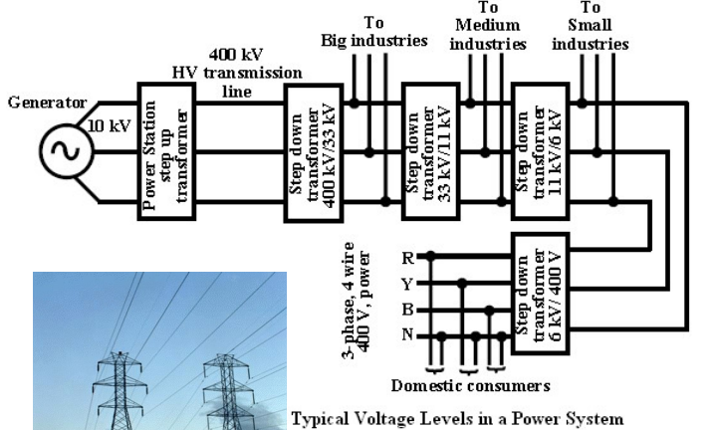

12. What are the load management strategies?

1. Load Curve Generation 2. Rescheduling of Loads 3. Storage of Products/process material like refrigeration

4. MD Control-by Shedding of Non-Essential Loads 5. Operation of Captive Diesel Generation Sets

6. Reactive Power Compensation

13. List down some of the important parameters that influence the motor selection.

(a) Torque requirement/load characteristics

(b) Ambient operating conditions

(c) Anticipated switching frequency

(d) Reliability

(e) Inventory

(f) Price

(g) efficiency

14. What are the merits of backward curve blade centrifugal fans?

The merits of backward curved blade centrifugal fans are:

a) High pressure generation

b) High efficiency

c) Power reduction with increased flow

15. Write short notes on energy saving opportunities in cooling towers

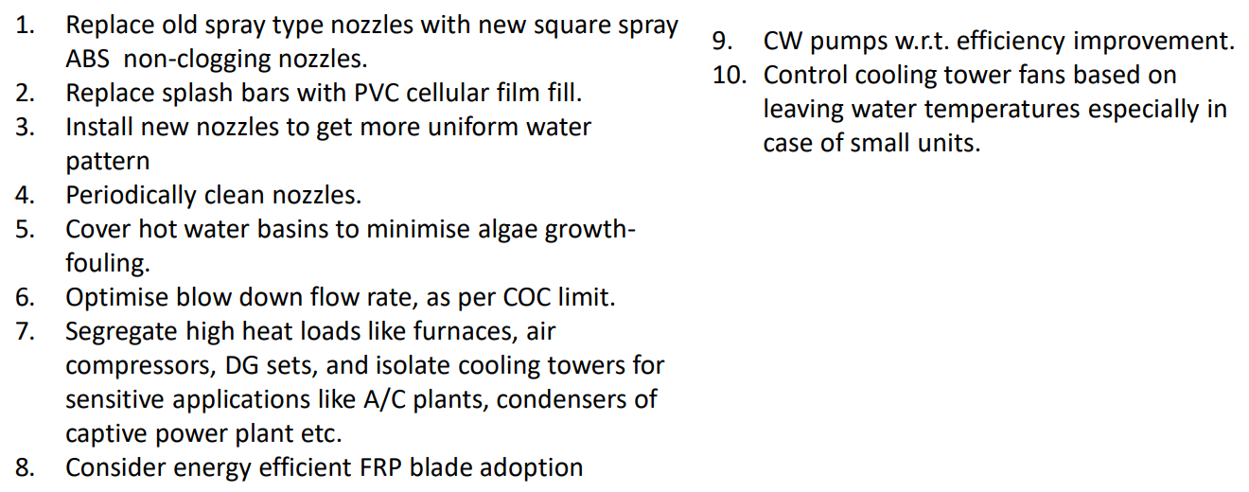

**PART – C (2 X 12 = 24 Marks)**

**Answer ALL questions**

16.a. List out all the general energy saving opportunities in lighting system.

1. Use natural day lighting

2. De-lamping to reduce excess lighting

3. Task lighting

4. Selection of high efficiency lamps and luminaries

5. Reduction of lighting feeder voltage

6. Electronic ballasts

7. Lighting controllers

8. Lighting maintenance

9. Clean light fixtures.

10. Consider lowering the fixtures

OR

16.b.i. For a load of 1500 KVA, plant has installed three numbers of 1000 KVA transformers. No load loss is 2.8 kW and full load loss 11.88 kW. Estimate the total loss with 3 transformers in operation and 2 transformers in operation. (6 Marks)

a) **2 transformers in operation** :

**No load loss** = 2 x 2.8 = **5.6**

**Load loss** = 2 x (750)2/1000 x 11.88

= **13.36 kW**

**Total Loss** = 5.6 + 13.36 = **18.96**

b) **3 transformers in operation :**

**No load loss** = 3 x 2.8 = **8.4 kW**

**Load loss** = 3 x (500)2 /1000 x 11.88 = 8.91kW

**Total loss** = **17.31 k W**

16.b. ii. Discuss the construction and operation principle of transformer with neat diagram. (6 Marks)

When the alternating current flows in the primary coils, a changing magnetic flux is generated around the primary coil. • The changing magnetic flux is transferred to the secondary coil through the iron core • The changing magnetic flux is cut by the secondary coil, hence induces an emf in the secondary coil

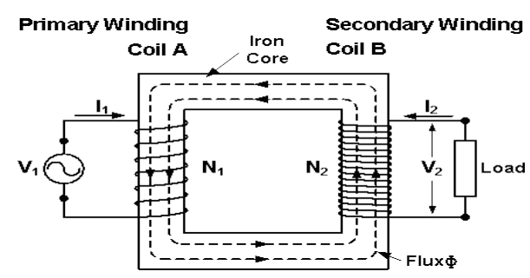

17.a. List the energy saving measures of diesel generator sets.

1. Ensure steady load conditions on the DG set,

2. provide cold, dust free air at intake

3. Improve air filtration.

4. Calibrate fuel injection pumps frequently.

5. Ensure compliance with maintenance checklist.

6. Ensure steady load conditions, avoiding fluctuations, imbalance in phases, harmonic loads.

7. For base load operation, consider waste heat recovery system steam generation or vapour absorption system adoption.

8. Consider parallel operation among the DG sets for improved loading

9. Carryout regular field trials to monitor DG set performance

OR

17.b. Explain the energy conservation opportunities in pumping system.

1.Ensure adequate NPSH at site of installation

2. Operate pumps near best efficiency point.

3. Modify pumping system/pumps losses to minimize throttling.

4. Adapt to wide load variation with variable speed drives

5. Stop running multiple pumps - add an auto- start for an on-line spare or add a booster pump in the problem area.

6. Conduct water balance to minimise water consumption

7. Replace old pumps by energy efficient pumps